Test Case: runTestMultipleTimes
Step 1 - Enter username and password and click to button Enter : Credentials Entered
Image file-name: QC_Testing-runTestMultipleTimes-dic. 03 2025, 09 26 43 a. m.

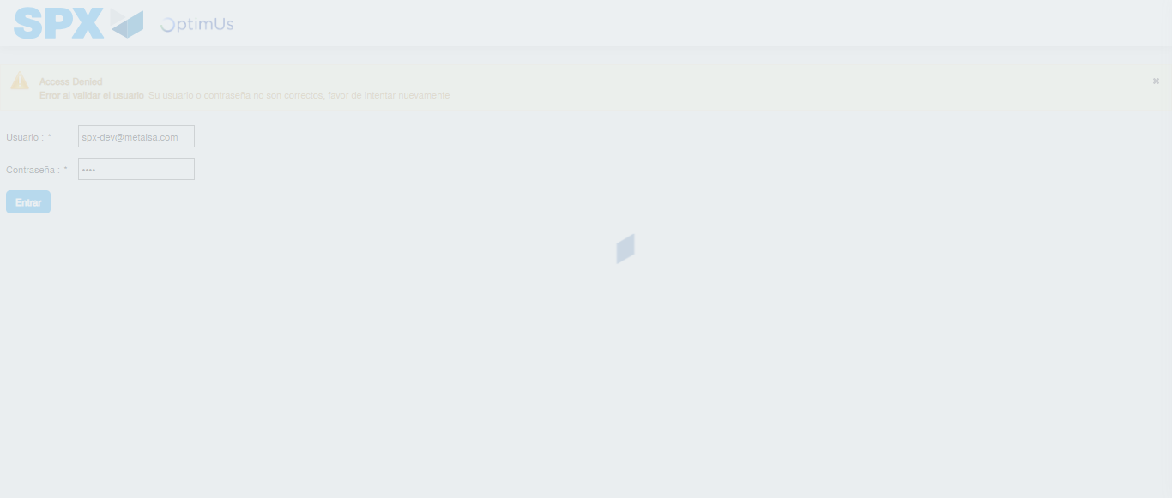Image file-name: QC_Testing-runTestMultipleTimes-dic. 03 2025, 09 26 44 a. m.

Step 2 - Select to UEN and Access to Administrador Roles Menu: UEN Correctly selected and Correct access
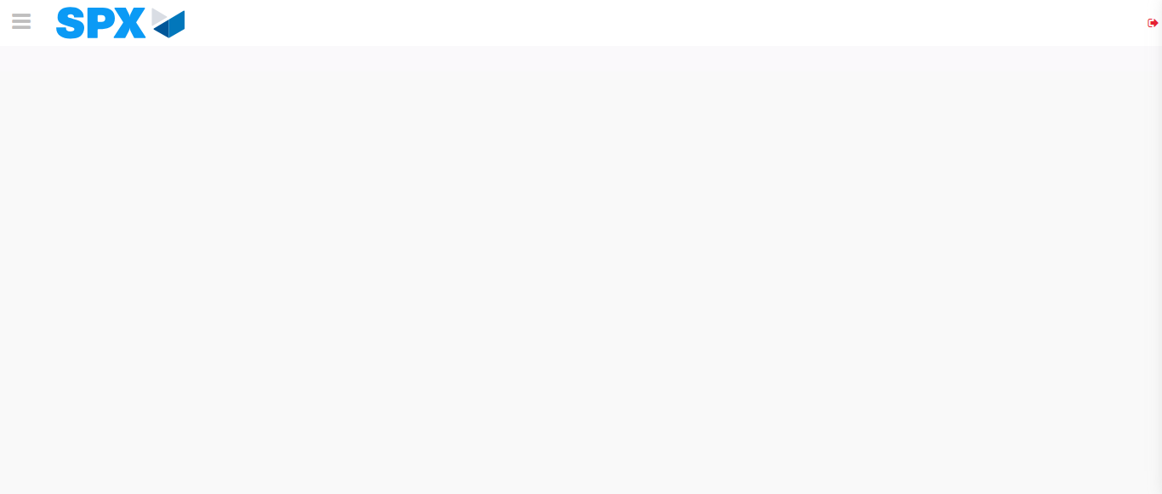Image file-name: QC_Testing-runTestMultipleTimes-dic. 03 2025, 09 26 47 a. m.

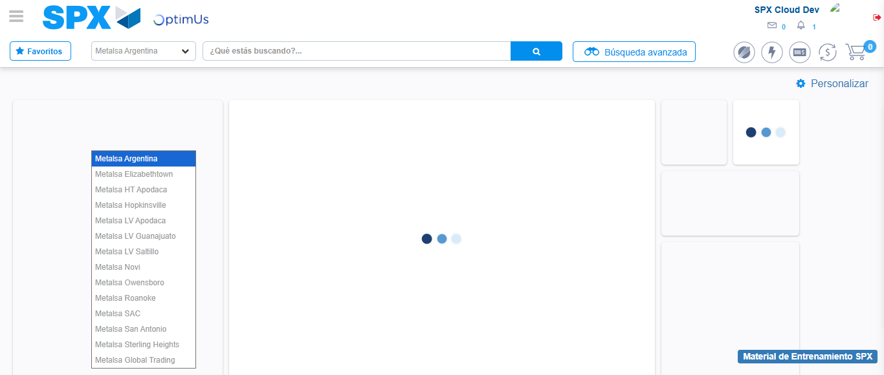Image file-name: QC_Testing-runTestMultipleTimes-dic. 03 2025, 09 26 48 a. m.

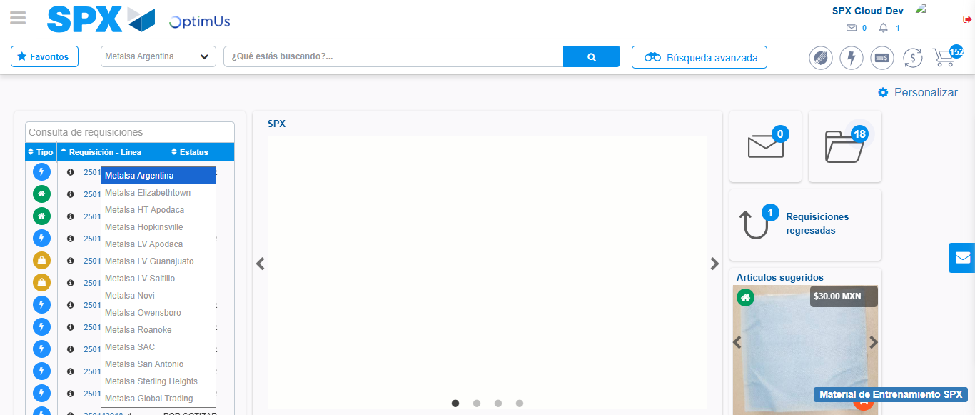Image file-name: QC_Testing-runTestMultipleTimes-dic. 03 2025, 09 26 49 a. m.

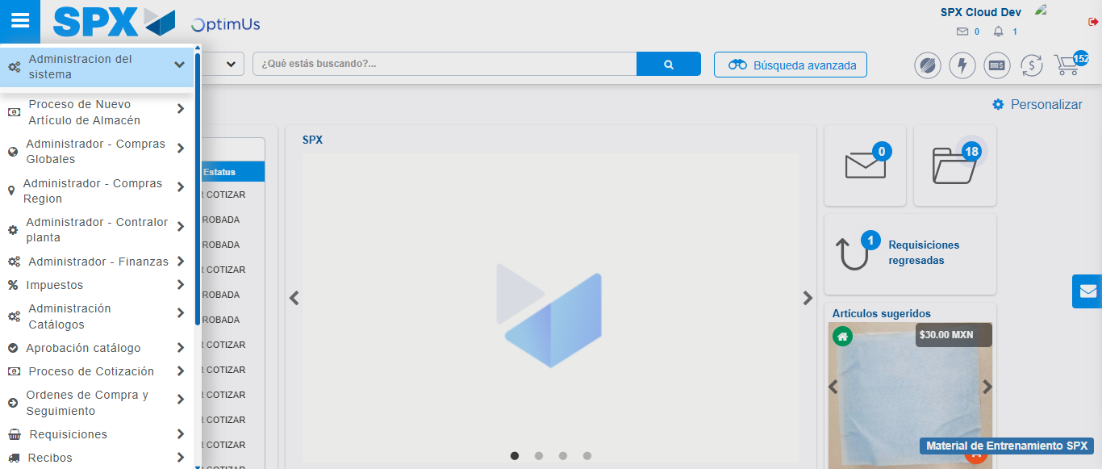Image file-name: QC_Testing-runTestMultipleTimes-dic. 03 2025, 09 26 50 a. m.

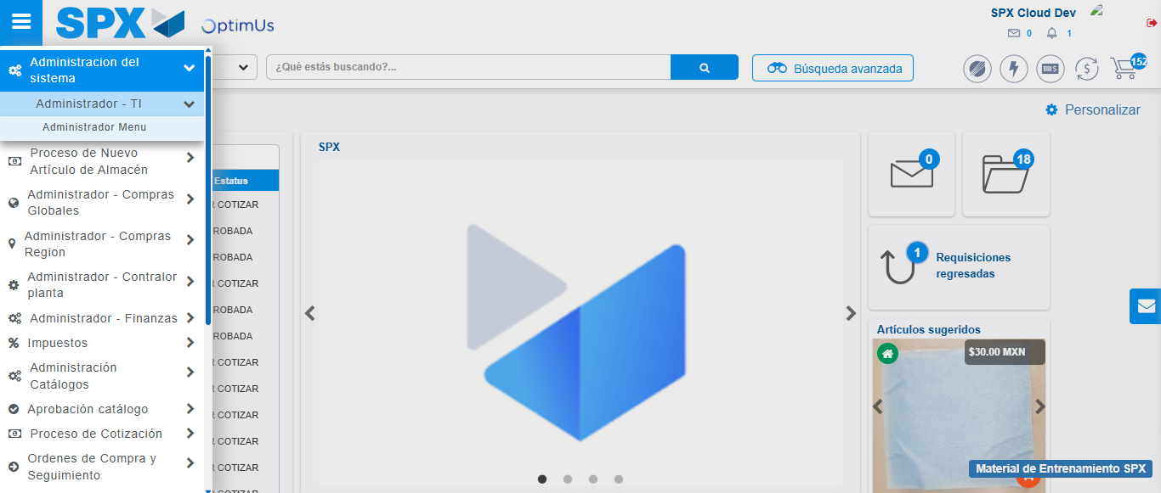Image file-name: QC_Testing-runTestMultipleTimes-dic. 03 2025, 09 26 51 a. m.

Image file-name: QC_Testing-runTestMultipleTimes-dic. 03 2025, 09 26 53 a. m.

Step 3 - Click to Buttons View Menu and Search Filter with Menu Name: Correct Search
Image file-name: QC_Testing-runTestMultipleTimes-dic. 03 2025, 09 26 53 a. m.

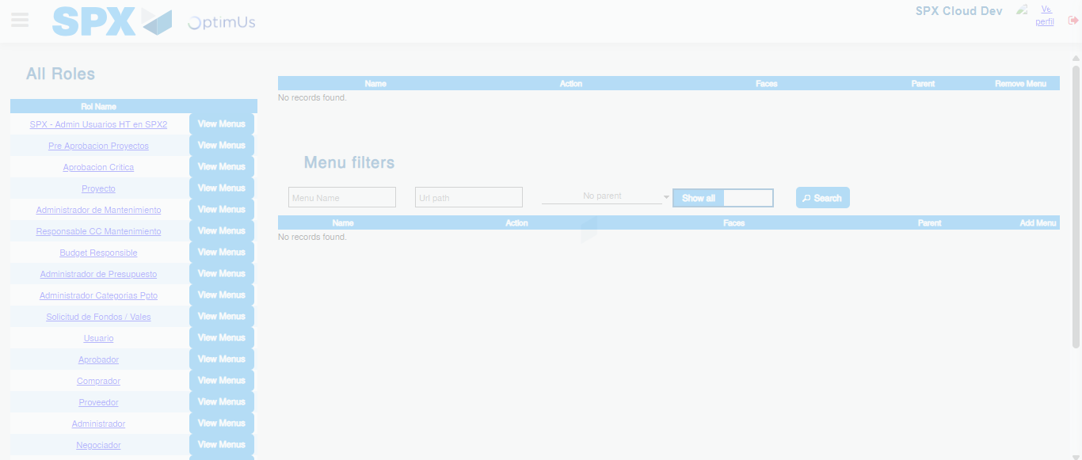Image file-name: QC_Testing-runTestMultipleTimes-dic. 03 2025, 09 26 54 a. m.

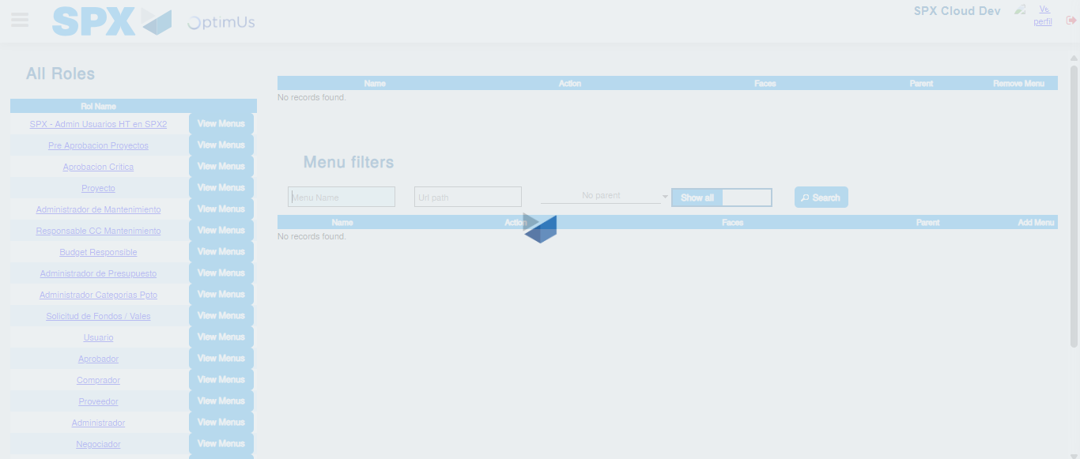Image file-name: QC_Testing-runTestMultipleTimes-dic. 03 2025, 09 26 55 a. m.

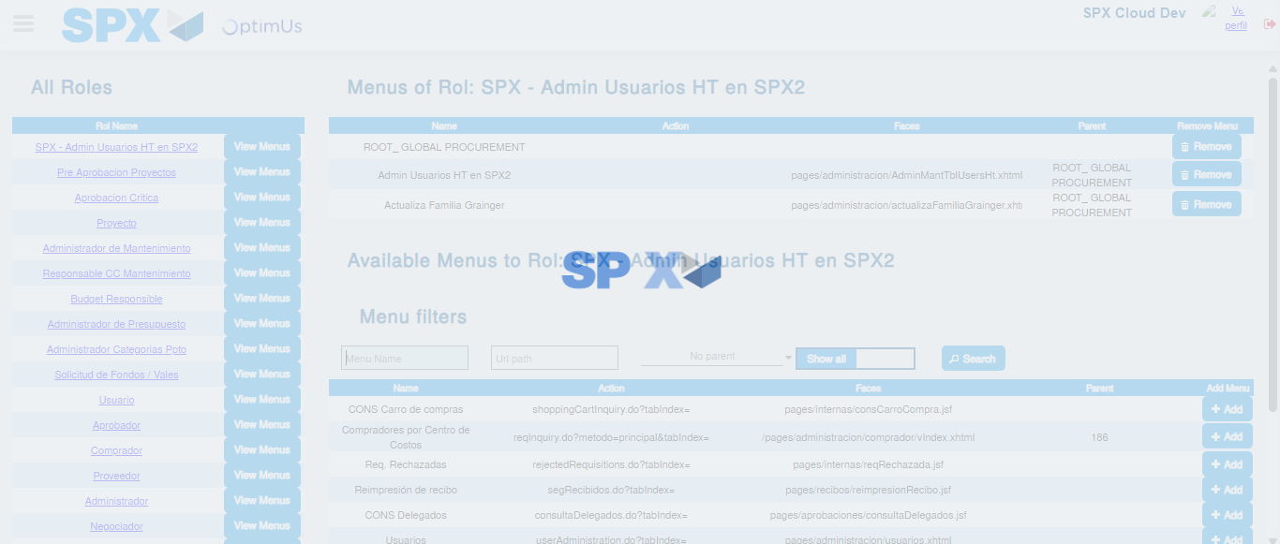Image file-name: QC_Testing-runTestMultipleTimes-dic. 03 2025, 09 26 56 a. m.

